TABLEAU NOTES

Ratios – Row level vs Aggregate level.

While dealing with ratios make sure to use aggregated ratios. Otherwise, we will get error results.

Data sample:

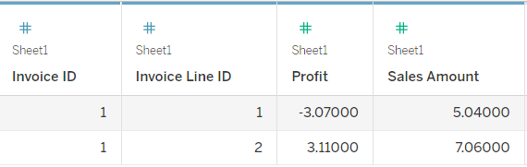

For e.g.,

Below are two calculated fields – one is row level and one is aggregated.

Profit ratio – row level

[Profit]/ [Sales Amount]

Profit ratio – Aggregation

SUM([Profit])/SUM ([Sales Amount])

And the result is given below,

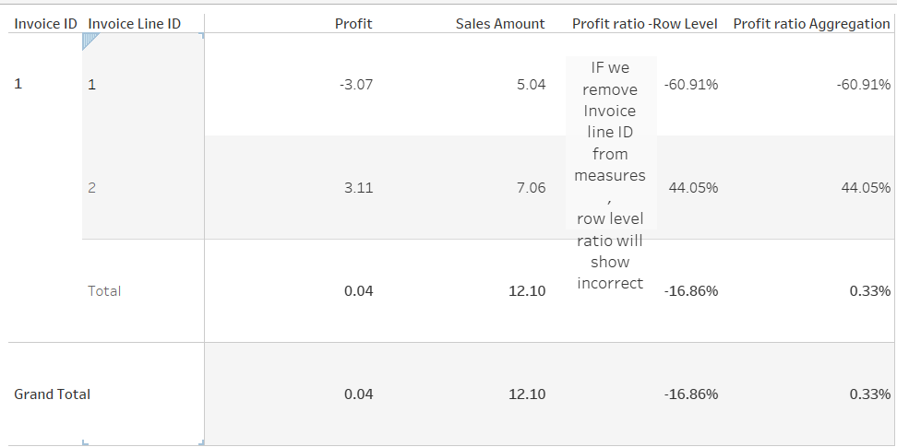

Even though at this level of detail the values are same, once we roll up or change the granularity, the values mismatch.

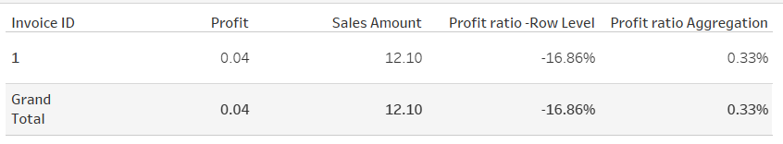

This is because in row level, first division happens and addition done as order of operation,

Whereas in aggregation first added up and then division is done, which will provide the correct output.

So, for calculations involving ratios make sure to use aggregations.